UAE Used Cars Analysis
Davis Vang
Jiaming Zhang
Natnael Berhanu
Metropolitan State University
STAT 311 Regression Analysis, Spring 2025
Dr. Iresha Premarathna
April 29, 2025

Introduction
This project investigates the factors that influence used car prices in the UAE. The primary research questions include: How does mileage affect the resale price of a car. Does automatic vs. manual transmission affect resale value? What are the key factors that influence used car prices in the UAE overall? Does the influence of mileage, when considering interaction terms, vary significantly in how it affects car prices based on the car brand or body type? Which subset of variables best predicts price? Is the relationship between mileage and price curved? These questions are important for understanding how different features of a used car, including mileage, brand, body type, and sale location, contribute to its market value. To address these questions, we used linear regression modeling, beginning with single-variable models and then moving to multivariable models that include dummy variables for categorical features. We will also conduct outlier analysis and consider stepwise selection methods to refine the models and identify the most significant predictors of used car prices. Car prices can really shift based on a bunch of factors, so running a regression analysis could just clear up things for buyers who would generally look for used cars.

Data Description
The dataset used in this project was sourced from Kaggle, the publisher Mohamed Saad, and is titled "UAE Used Cars Analysis." It contains 10,000 individual listings of used cars for sale across the United Arab Emirates, including major cities such as Dubai, Abu Dhabi, and Sharjah. Each listing includes a range of features that are critical for understanding market value, such as the car’s make and model, manufacturing year, price, mileage, fuel type, transmission, body type, engine size, and location. These variables work greatly with the research questions mentioned in this analysis, particularly around how factors like mileage, brand, body type, and city influence resale price. The data appears to have been collected through web scraping of public car sale platforms, likely during a single time period to create a snapshot of the market. After collecting the data, it was cleaned and preprocessed. Brand names are standardized, categorical variables are clearly defined, and numerical values (e.g., mileage and price) are formatted for analysis. This dataset provides a practical foundation for regression-based modeling and price prediction, allowing us to explore general trends and specific connections between car features and price. Also, adding geographic data helps in the backup analysis looking into how location affects car pricing across the UAE.

Exploratory Data Analysis
We aimed for a straightforward question that many people have often contemplated in purchasing a car: “How many miles are involved, and what is the cost associated with that distance?” Most likely the average customer would lean on the type of car and model of their preference as well, therefore adding that into our model. This question will allow us to look more into what variables cause the price difference in cars. In the model, there was a huge skew of prices with a minimum of $7183 to a maximum of $14,686,975. With several variables affecting prices, there was, Make, Cylinders, Fuel Type, Body Type, Color, Location, Mileage, Year and Transmission. To put it in terms the average American can relate to, by comparing the statistics before and after filtering out the expensive cars that were outliers, it seems that the average mean of price would be $90,432 compared to the average mean of $245,234.

- Distribution and statistics of Price before filtering
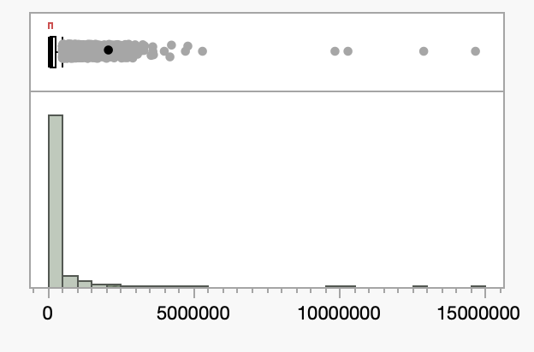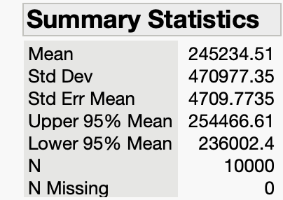
- Distribution and statistics of Price after filtering
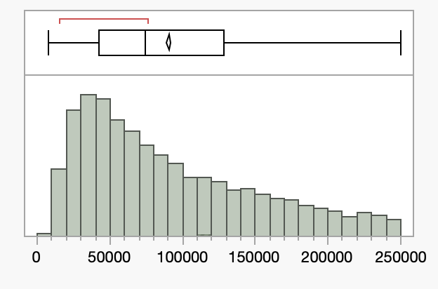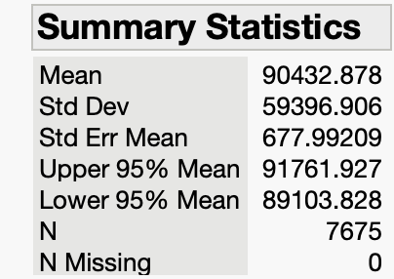

Method
To investigate what affects used car prices in the UAE, we utilized various linear regression techniques, starting from straightforward models and gradually moving to more sophisticated ones. We kicked off with a univariate linear regression model focusing on mileage as the only factor influencing price (Model 1), which helped us grasp the basic link between how much a car has been used and its resale value. After that, we introduced multivariable models that included both continuous and categorical variables, such as make (brand), body type, transmission type, fuel type, color, year, location, and number of cylinders, using dummy coding. To measure the effectiveness of our models, we used R-squared (R²) and Adjusted R² to evaluate how well they fit the data, along with F-tests and t-tests to determine statistical significance. We also performed residual diagnostics, like the Durbin-Watson statistic, to check for autocorrelation and assess how well the models performed. For selecting the right variables, we implemented stepwise regression (Model 5), applying both forward selection and the Bayesian Information Criterion (BIC) to pinpoint the most significant variables with reduced complexity. Additionally, we looked into the interaction effects between mileage and various categorical variables such as make (Model 4), and explored non-linear relationships using polynomial and interaction terms (Model 6). This helped us determine if curvilinear patterns or combinations of predictors explained price variations more effectively. This careful method allowed us to improve our models over time, helping us to identify the main factors that affect used car prices while keeping things straightforward and easy to understand.

Results
The results from the models provide us information about the prices of used cars in the UAE. Each model explains how various factors contribute to the rise in price based on different variables.
- Model 1:
- $E\left(y\right)=β_{0}+β_{1}x_{1}$
- This is the most basic model. It includes just one predictor: Mileage, representing the total kilometers driven by the car. This model helps us examine whether usage alone is a strong predictor of a car’s resale value, without considering factors like brand, year, or location.
- Hypothesis
- Tables:
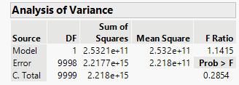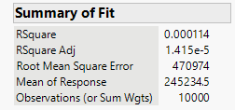
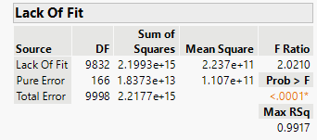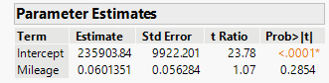
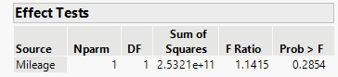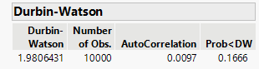
- Model Summary:
  - R² = 0.0001
  - Adjusted R² = 0.00001
  - F Ratio = 1.1415
  - Model p-value = 0.2854
  - Mileage p-value = 0.2854
  - Durbin-Watson = 1.98 (no autocorrelation)
  - RMSE = 470,974
- Interpretation:
  - The global F-test shows that the model is not statistically significant overall. The t-test shows that mileage is not a significant predictor of car price, with a p-value of 0.2854.
  - The price is very low, meaning mileage explains almost none of the variation in price. Surprisingly, the coefficient for mileage is slightly positive, which may be due to outliers or missing variables.
  - The lack-of-fit test is significant, meaning the model is missing structure — which makes sense since it only includes mileage.
- Conclusion:
  - Model 1 explains almost none of the variation in used car prices. It does not fit the data well and is missing key predictors. More variables (like brand, year, and location) should be added in the next model to improve accuracy.
- Model 2:
- Automatic vs. manual transmission affect resale value?
- $H_{0 }=β_{1}=β_{2}=β_{3}=β_{4} = β_{74 }= 0 vs H_{a }: At least one β=0$
- Interperation:
  - This model includes multiple categorical variables such as brand and body type, in addition to mileage and transmission. The global F-test shows that the model is highly statistically significant (p < 0.0001), meaning that the predictors collectively help explain the variation in car price. The R² of 0.4792 shows that the model explains about 48% of the variation in used car prices—much better than simpler models before.
  - While the overall model is strong, some individual variables (like Mileage and Transmission) have high p-values (0.3505 and 0.5728), meaning they are not significant on their own in this full model. However, many car brands (e.g., Ferrari, Rolls-Royce, Mercedes-Maybach) and body types (like SUV, Sports Car, Sedan) are significant predictors, as seen in their low p-values. This shows that brand and body type are very important in determining used car prices.
  - The Durbin-Watson statistic is about 2, suggesting no autocorrelation in residuals. The residual plot appears fairly homoscedastic, though still with some spread, which is expected with real-world data.
- Tables and graphs
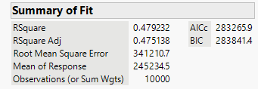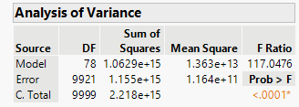
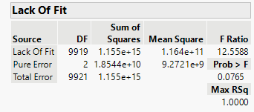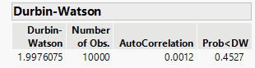
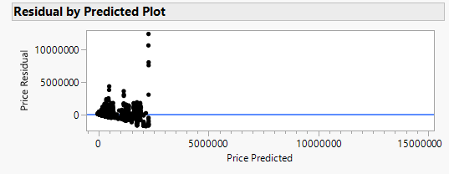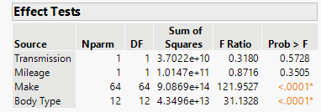
- Conclusion
  - Adding brand and body type to the model significantly improved performance. This model is much better than using mileage or transmission alone. Mileage by itself is still not very useful, but combining it with brand and body type produces a solid model. The next step could involve adding other features like year, location, and fuel type to refine prediction even more.
- Model 3
- What are the most important predictors of car price? This model was used to figure what particular variables cause the most increase in price. R² = 0.52, so it explains about 52% of the variance in used car prices, which is strong for real-world pricing models. P-value for the overall model < 0.0001. This means at least one predictor is significantly associated with car price. The most important predictors of car price happened to be, make, body type, cylinders, fuel type, color and location.
- $E\left(y\right)=β_{0}+β_{1}x_{1}+β_{2}x_{2}+β_{3}x_{3}+β_{4}x_{4}+β_{5}x_{5}+β_{6}x_{6}+β_{7}x_{7}+β_{8}x_{8}+β_{9}x_{9}$
- Tables of Graphs:
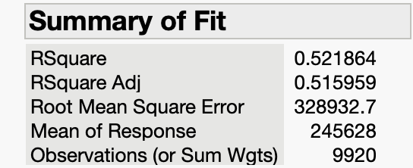
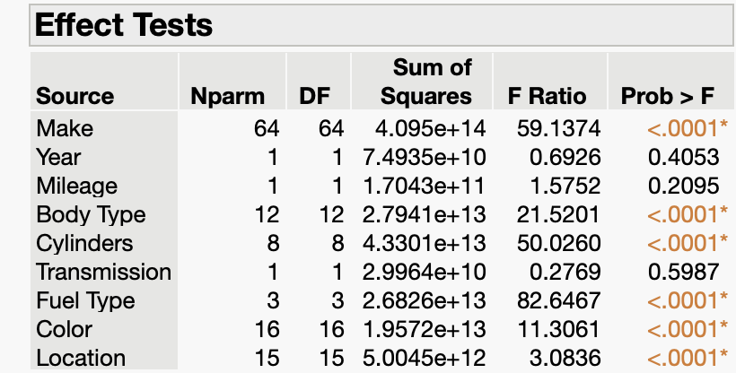
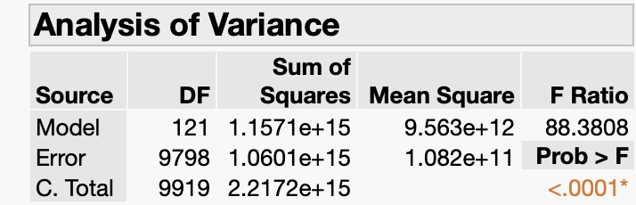
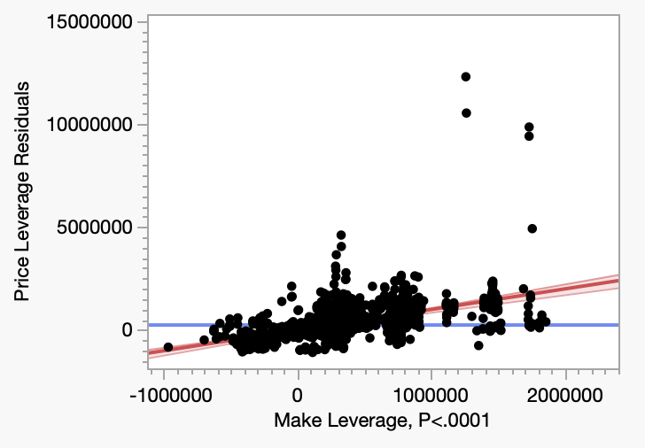
- Interpretation
  - With the graph shown, it had the most increase based on the make of car. Many of the other graphs featuring different variables that showed a low p-value had more of a bland look to the graphs. Therefore the most increase in price for cars happened to be the make of the car.
- Model 4
- This model we decided to look more into the effect of mileage differences across car types or brands. R² had a 37% which means this model only explains 37% of the variance in used car prices. Both had a low p-value but the higher f ratio happened to be the make, which would make sense because a make of ferrari would be different to a honda with same mileage.
- $E\left(y\right)=β_{0}+β_{1}x_{1}x_{2}+β_{2}x_{1}x_{3}$
- Tables:
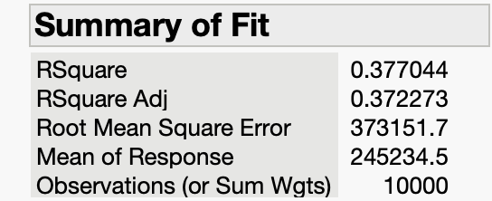
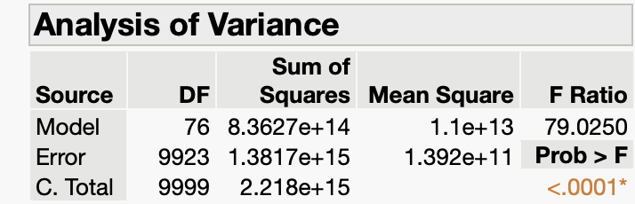
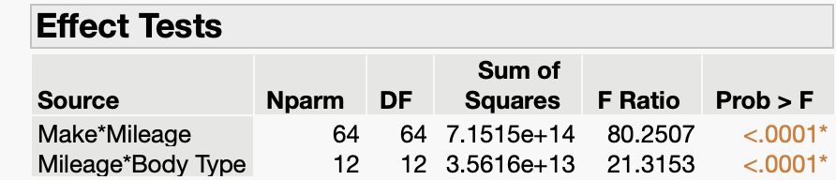
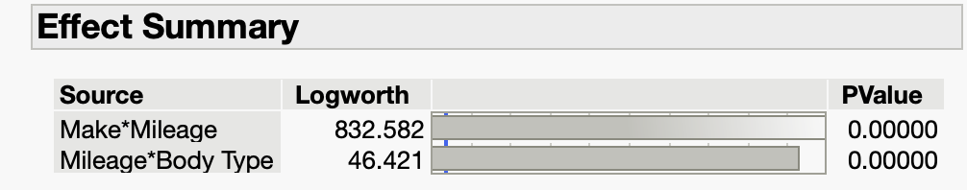
- Interpretation:
  - Looking at the logworths or F ratio, it’s clear that the make matters the most considering the price within mileage of the cars.
- Model 5 Stepwise model
- In this model, we use the stepwise test model to examine which variables in the data ( whether continuous or nominal) contribute more to the model. First, we try the forward + Minimum BICC.
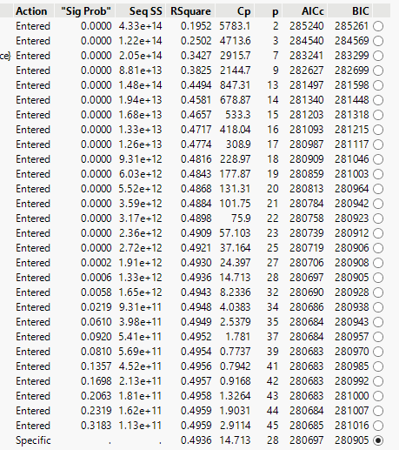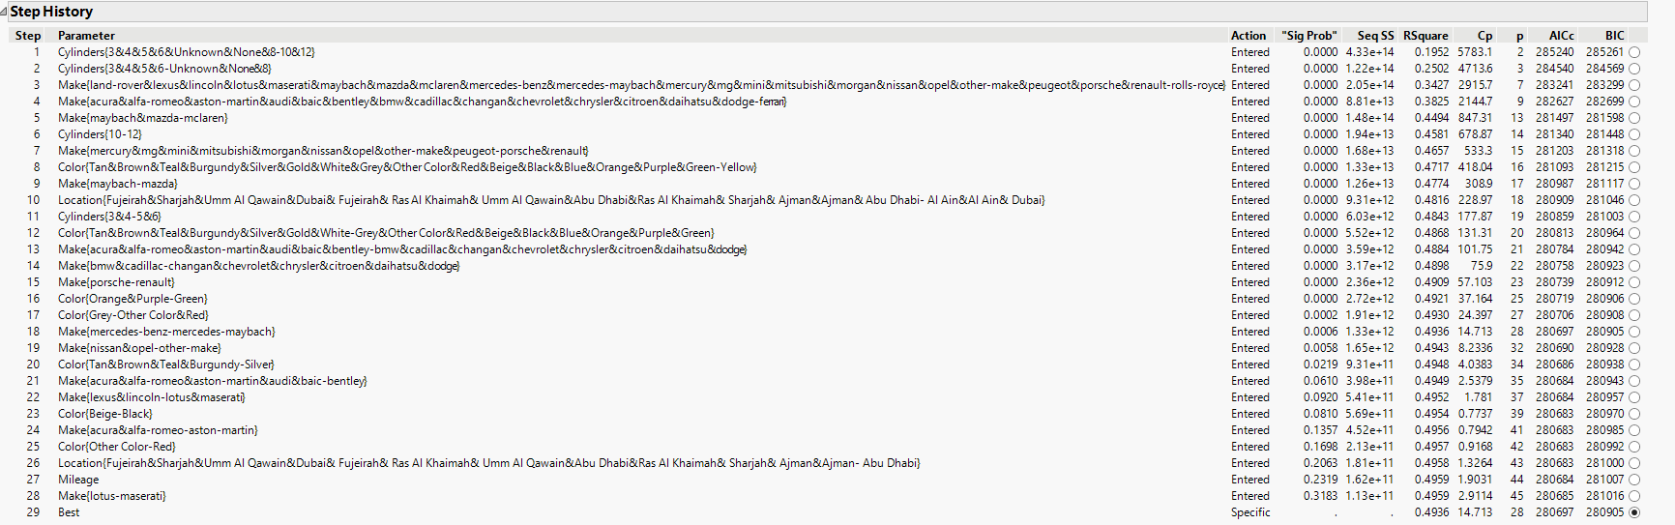
- For minimum BICC
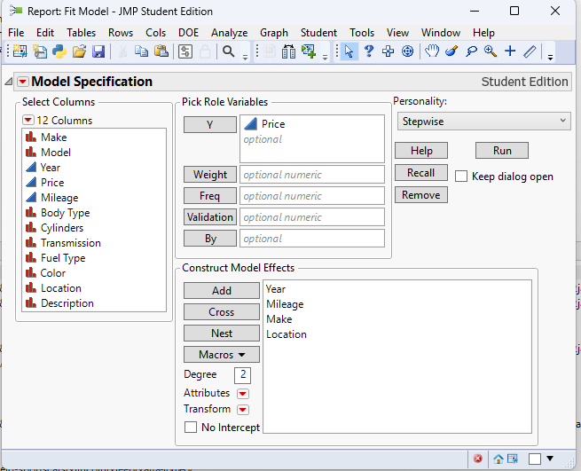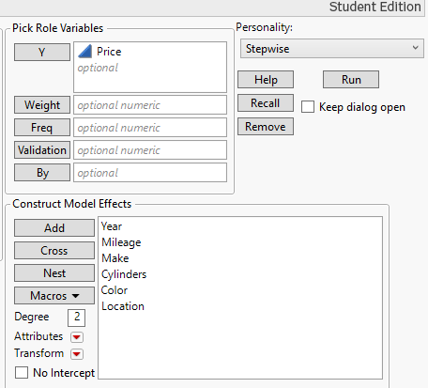
- The model dialog2, using different variables. For this model, we choose Year, Mileage, Make and Location.
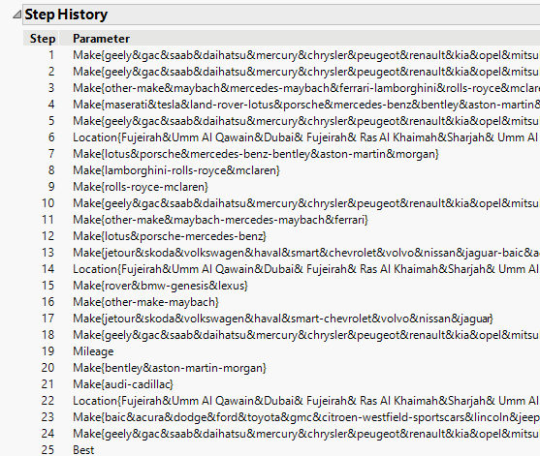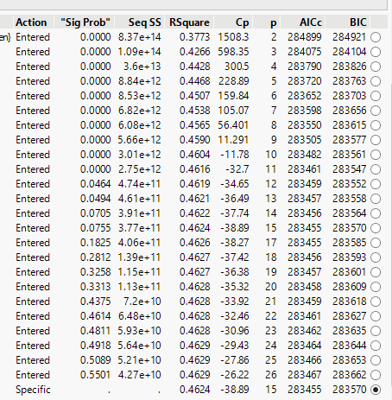
- This is the outcome for the second try stepwise.
  - The model starts with an RSquare of 0.3773( 37.73% variance explained) with 2 parameters. It reaches a peak RSquare of 0.4629 with 26 parameters, and the most significant improvements occur in the first 6 steps. The table suggests the best model occurs at step 15 with RSquare = 0.4624 and the lowest cp of -38.39. After step 15, adding more variables provides minimal improvement while increasing complexity. The recommendation is select the 15-variable model as it appears to be the optimal balance between complexity and explanatory power. When we take closer look at the stepwise model, we can see all the steps within the 15 steps are within make and location, which give us the expression of the importance of location and make. However, since the brand and year do have importance within common knowledge, we can compare the model by only select the year and brand for 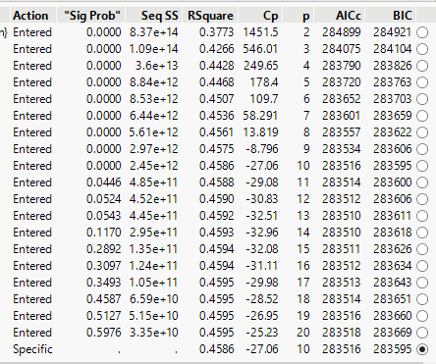
stepwise test to compare the Cp value, AICc and BIC value. Here is the compared model with only brand and year as the independent variable, remove all the dummy variables.
- Over the process, only brands are selected and the highest RSquare value reaches 0.4595, which is near the same compared with the former model and tests in the stepwise model. Other findings in this model is that the result reaches the best option when it comes to step 10. The statistics result for step 10 includes:
  - RSquare : 0.4586
  - Cp: -27.06 (Minimum in this range)
  - AICc: 283516
  - BIC: 283595 ( Lowest BIC value)
- After step 10, adding more variables provides negligible improvement. Compared with the former model, this model selection has a more dramatic drop in Cp value from -27.06 to -38.89. The 10-variable model provides a better balance in the explanatory power and fewer variables. Overall, the initial model( with all variables) achieved an RSquare of ~ 46.3%, while the restricted model reached 45.9%, indicating that brand and year are the dominant predictors. The 10-variable model offered the best balance of parsimony and performance, with the lowest BIC and a strong Cp statistic (-27.06). The 15-variable model slightly improved RSquare but at the cost of added complexity, making it less efficient unless the marginal gain is critical. The stepwise regression confirms that brand and year are the most influential factors, with diminishing returns from additional variables. A simpler model (10 predictors) may be preferable unless a slight RSquare boost justifies complexity. Further refinement with regularization techniques or machine learning models is recommended for better generalization.
- Model 6
- Tables: 6
- Steps: This model checks whether the relationship between mileage and price is curved rather than purely linear. We added a squared mileage term (Mileage²) to capture possible non-linear trends such as quadratic depreciation. If mileage affects price in a non-linear way (e.g., depreciation accelerates after a certain point), this model should detect that.
- Hypotheses:
H0:β_1 =β_2 =0 vs H_A :At least one β_i≠0
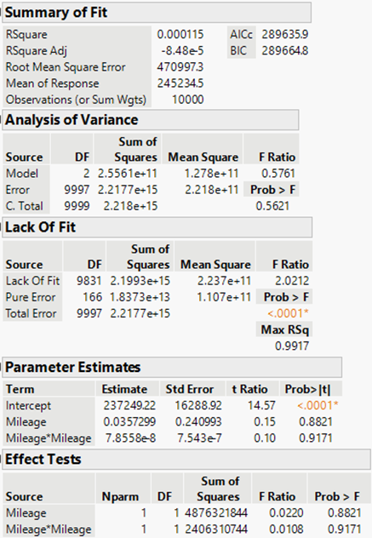
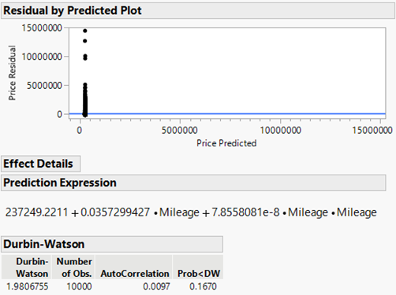
- Model Summary:
R² = 0.000115
Adjusted R² = –0.0000848
F Ratio = 0.5761
Mileage p-value = 0.8821
Mileage² p-value = 0.9171
Durbin-Watson = 1.98 (no autocorrelation)
RMSE = 470,997 AED
- The F-test shows the model is not statistically significant (p = 0.5621), and both mileage and mileage² have very high p-values, meaning neither is a significant predictor of price. The R² value is extremely low, indicating that almost none of the variation in car price is explained by mileage, even when including the squared term. The adjusted R² is negative, which typically signals that the added variable (Mileage²) did not improve the model and may have introduced noise. The lack-of-fit test is still significant, suggesting missing structure remains. The residual plot also shows a wide scatter with no clear pattern, reinforcing that mileage does not explain much.
- Conclusion: Adding a non-linear term (Mileage²) did not help improve the model. Both the original and squared mileage terms are statistically insignificant. This model confirms that mileage alone, even with a non-linear adjustment, is not useful for predicting used car prices in this dataset. To improve prediction, additional variables like brand, year, location, and transmission are needed.
Conclusion
This study explored the main factors that affect used car prices in the UAE through various regression modeling techniques. We started with a basic model that looked only at mileage, and it turned out that mileage by itself wasn't a strong predictor of price, explaining almost none of the variations in resale values. As we added more complexity to the models by including categorical variables such as transmission type, body type, make, location, and year, we saw a significant improvement in explanatory power. In Model 3, we found that factors like make, body type, fuel type, number of cylinders, and location had a substantial impact on price, achieving an R² value of 0.52, which was the highest of all the models tested. We then looked further into the interactions between mileage and make in Model 4, confirming that mileage's effect on price does indeed vary depending on the brand. The stepwise regression models (Models 5 and 6) reinforced the idea that make and year are the most significant predictors. The 10-variable model provided a nearly optimal balance between complexity and predictive accuracy, with an R² around 0.46. Model 6 also examined curvilinear relationships and verified that although non-linear effects were present, the main predictive factors stayed consistent, with make being the most influential on price. In summary, this analysis highlights that while factors like mileage and year play a minor role, the make of the car and its location are the most crucial elements in determining used car prices in the UAE.

